Olasinde A. A**,** et al. - Use Of Free Non Vascularized Fibular Intramedullary Strut Graft As Adjunct To Dynamic Compression Plate In Severe Atrophic Fracture Non Union In Young Adult

Western Nigeria Journal of Medicine May/June 2010 Vol. 3

# Use Of Free Non Vascularized Fibular Intramedullary Strut Graft As Adjunct To Dynamic Compression Plate In Severe Atrophic Fracture Non Union In Young Adult

Olasinde A. A**,** Adetan O**,** Oluwasanjo M**,** Atimo C. O

Department of Orthopaedic Surgery and Traumatology Federal Medical Centre

Owo, Ondo State, Nigeria

Correspondence to: Olasinde A. A [, email:olasindetony@yahoo.com](mailto:olasindetony@yahoo.com)

###### Abstract

**Background:** *Operative treatment of atrophic fracture non union of long bone with the use of dynamic compression plate poses a serious challenge to orthopaedic surgeons in developing countries due to difficulty of ensuring firm purchase by the screw in the bone. Ilizarov fixator, locking plates and free vascularized fibular graft are viable options which may not be readily available due to cost and lack of expertise.*

**Patients and Methods:** *We report the use of free fibular intramedullary strut graft to bridge the fracture site in order to enhance the pull out strength of the screws of dynamic compression plate in operative treatment of severe atrophic fracture non union involving the femur and humerus in two young adults.*

**Result:** *The patients progressed to successful union of the fractures at the last follow up without recourse to additional iliac crest bone grafting.*

**Conclusion:** *Free fibular intramedullary strut graft as adjunct to dynamic compression plating in severe atrophic fracture non union of long bone is a feasible, readily available and useful option especially to surgeons in developing countries faced with this challenge.*

###### Introduction

With continued patronage of traditional bone setters by patients in our environment, fracture non union of long bones has remained a common presentation to Orthopaedic surgeons practicing in Nigeria. 1 Most often, the predominant type of fracture non union is the atrophic variant posing a considerable operative fixation challenge to the surgeons due to the limited choice of implants available for use. The challenge is the difficulty encountered in ensuring a firm screw grip in disuse osteoporotic fractures. To overcome this problem, locking plates and use of polymethyl methacrylate screws are of considerable advantage, but high cost and availability are concerns in our country2. The Ilizarov technique is another option but expertise in its use may not be commonly available.3There is a report on the use of free fibular intramedullary strut graft as adjunct to plating of osteoporotic humeral shaft fracture non union in an elderly patient which progressed to uneventful union with out the need for additional iliac crest bone grafting. 4 We report the use of this technique in two young adults with severe atrophic non union of fractures of the humerus and femur who finally progressed to union without recourse to other procedures.

###### Patients And Methods

Two consecutive patients with severe atrophic non

Western Nigeria Journal of Medical Sciences. May/June 2010; 3

union of the femur and humerus were treated in 2009 in our centre; which is a tertiary health institution. We used free fibular intramedullary strut graft and dynamic compression plating (DCP). We defined non union as fractures which had remained un united for at least nine month in femoral fractures and 4months in humeral fractures3.

The patients underwent surgery under general anesthesia after administration of prophylactic antibiotics.

###### Preparation of The Free Non Vaslurized Fibular Graft

The mid shaft of the fibula was harvested with care to protect the superficial peroneal nerve at the neck. The shaft of the fibular was harvested in excess

motion at the knee was 30 degrees with pain-free mobility in the distal third of the thigh, about 6cm above the knee. The radiograph revealed non union of a distal third femoral fracture with resorption of bone ends.( Figure 1)

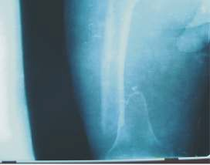

**Figure 1: Preoperative radiograph showing atrophic non union of supracondylar femoral fracture.**

length to permit trimming as may be necessary.

He was operated on the 17th

September 2009.

Three sides of the fibular were trimmed so that it could telescope in the fracture fragment across the fracture sites without breaking. When the thickness of the graft did not permit its use it was conversely bevelled at two ends to leave the full thickness in the middle which can later bridge the non union site. The strut was pushed into one of the fracture fragments and the exact length of graft that needed trimming

Operative findings were fibrous soft tissue interposition between the fracture fragments which had rounded and friable bone ends. The medullary canals of the fractures were opened and the ends of the fragments were freshened till free bleeding was obtained Free fibular graft was harvested from the ipsilateral leg as described above. A 95 degree angled blade plate was passed appropriately in the

was assessed. Once the final shaping of graft was

distal fragment. 6

Due to the friable status of the

done, the fracture was reduced with intramedullary graft spanning the fracture site.

Case 1

Mr AU, a 40year old security guard, a non smoker, presented 2 years after a road traffic crash injury with atrophic non union of the left femoral fracture and 3 centimeter (cm) shortening. He has been treated previously by traditional bone setters. He had no history of co-morbid medical problem. Examination revealed atrophy of left thigh with mid thigh circumference differential of 3 cm. the range of

condyles, this was secured with bone cement and osteosynthesis across the fracture site achieved with cortical screws. The immediate post operative radiograph showed good reduction (figure 2).

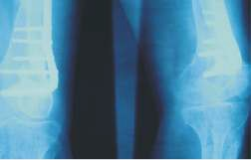

**Figure 2: Immediate post operative radiographs.**

Olasinde A. A**,** et al. - Use Of Free Non Vascularized Fibular Intramedullary Strut Graft As Adjunct To Dynamic Compression Plate In Severe Atrophic Fracture Non Union In Young Adult

The knee underwent passive joint manipulation at the end of the surgery. Patient was mobilized on non weight bearing bilateral axillary crutches till osteointegration of the fibula and fracture healing took place. Then, partial weight bearing was commenced. Serial radiographs were taken in two orthogonal planes to assess fracture healing. The fracture was taken to have united when three cortices on radiograph showed bone trabeculae across the fracture site. Union of the fracture occurred at 6months. The range of movement of the knee increased to 90 degree (Figure 3).

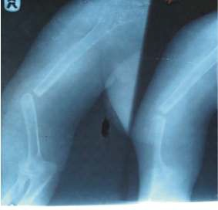

**Figure 4:**

**Radiograph showing atrophic non union of the humerus**

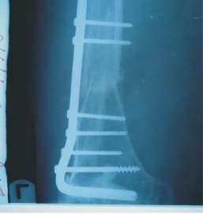She was operated on the 18th

of October 2009.

**Figure 3:**

**Post operative radiograph with free fibular intramedullary graft and fixed 95 degrees angled blade plate taken at six month.**

Case 2

Mrs AB, a 27 year old housewife presented 8 months after road traffic injury with atrophic non union of right humeral fracture and a history of previous treatment by the traditional bone setters. There was no co-morbid medical illness. Examination revealed wasting of the right biceps and triceps muscles and stiffness of the elbow and shoulder. There was no neurological deficit.

Radiograph showed atrophic non union and resorption of end of the bone fragments. (Figure 4)

Operative finding was non union of the midshaft of right humerus with intervening soft tissue and friable bone ends. The bone ends were freshened till free bleeding was obtained and medullary cavity opened. Free fibular strut graft was placed as previously described. The immediate post operative radiograph was satisfactory (Figure 5).

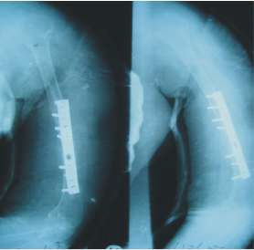

**Figure 5:**

**Immediate post operative radiographs temporarily protected in U- cast**

The patient had uneventful postoperative recovery and was placed on exercise therapy to increase the range of movement of the elbow and shoulder. The

Western Nigeria Journal of Medical Sciences. May/June 2010; 3

fracture progressed to uneventful union at 8 week with normal range of movement of the elbow and shoulder (Figure 6)

three of their six patients had previous treatment from traditional bone setters.3

In developed countries locking compression plating is useful in operative fixation of atrophic fracture non union but in developing countries, the problems of

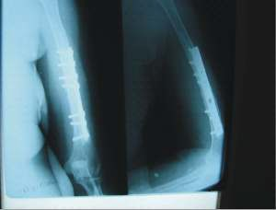cost and availability make this impossible.3

The

**Figure 6:**

**Radiograph taken at six months post operatively of the humerus showing gradual incorporation of the fibular graft and healed fracture.**

###### Discussion

Non union is gradually becoming a common pattern of presentation of long bone fractures in our

Ilizarov external fixation is another promising option for the management of this problem; however its complexity, technical difficulty, the commitment of time and resources required for a good result are some of its major draw backs.4, 5 The surgeon in our environment is left with no other option than dynamic compression plating which is familiar, easy to use, readily available and affordable.

In order to overcome the problem of screw pull out from atrophic bone during compression plating, some authors have recommended the use of polymethyl methacrylate bone cement along with

environment.

1 The continued patronage of

the cortical screws to enhance the pullout strength

traditional bone setter remains a major factor contributing to this. Non union can be hypertrophic or atrophic. The hypertrophic variants are found in young adults whose fractures are improperly immobilized during treatment. This may lead to pseudoarthrosis with elephant foot appearance. This is easily amenable to compression plating without recourse to other option of ensuring stability. However atrophic type is not common in young adults. When it occurs it usually arises from a combination of factors in addition to poor immobilization. The two patients in this study had previously visited traditional bone setters. Their mode of fracture treatment involves the tying of woven basket made from raffia palm around the limbs. When this is applied too tightly as is often the case, it leads to compromise of blood supply to the limb and bone. In the series from India on humeral fracture non union in the elderly osteoporotic bone,

but this adds to the cost and has the potential for

cardio toxicity. 2

The fibula is known to transmit one eighth of the body weight and it is useful as vascularized or non- vascularized graft. The non vascularized fibula is easy to harvest with minimal tissue trauma. It is important to leave a few centimeters of the epiphyseal portions in place so as not to interfere with the joints involved. In addition to acting as a strut across the fracture site, the cortical nature of the harvest affords immediate structural continuity and stability with some osteogenic potential when used as intramedullary bone graft. It should be noted that there is small but inherent disadvantages of its slow revascularization and reincorporation. The risk to common peroneal nerve in fibula harvest is a complication which can be avoided by identifying and protecting the nerve during exposure.

The two patients in this case report healed

Olasinde A. A**,** et al. - Use Of Free Non Vascularized Fibular Intramedullary Strut Graft As Adjunct To Dynamic Compression Plate In Severe Atrophic Fracture Non Union In Young Adult

uneventfully when free fibular intramedullary strut graft was used to enhance the pull out strength of the cortical screw. This has the dual advantages of ease of use and reliability. There was no complication in the two patients. The radiograph done at six months post operatively showed gradual and progressive incorporation of the graft as well as callus formation at the non union site. There was no donor site morbidity.

It can be concluded that an intramedullary fibular strut graft across fracture site in conjunction with dynamic compression plating achieves union successfully in fractures non union of long bone without recourse to secondary procedure such as cancellous bone grafting.

###### Reference:

1. Omololu B Ogunlade SO Alonge TO. The complications seen from traditional bone setters. West Afri. J. Med. 2002; 21(4): 335-7
2. Cameron HU Jacob R Mac Nab I Pillar RM. Use of polymethyl Methacrylate to enhance the screw fixation in bone. J. Bone Joint Surg. (Am) 1975; 57; 655-6
3. Vidyadharu S Vamsi K Rao SK, Gnanadoss JJ, Pandian S. Use of intramedullary fibular strut graft : A novel adjunct to plating in the treatment of osteoporotic humeral shaft non union. Int. Orthop. 2009; 33: 1009-14
4. Ilizarov GA Transosseous osteosynthesis: theoretical and clinical aspects of the regeneration and growth of tissue. 1992. Springer. Berlin
5. Paley D. Problems, obstacles and complication of limb lengthening by Ilizarov technique. Clin. Orthop.1990; 250:81-104
6. Schatzker J. Supracondylar fractures of the femur. In: Schatzker J, Tile M, eds. The

Rationale of Operative Fracture Care.

*New York, NY:*. Springer-Verlag;1987:255- 273.